OpenCart Website
Tutorial 9 — Black-Box, White-Box, Integration & System Testing
Module Name: OpenCart – Login Module (Black-Box, White-Box, Integration, System)
Report ID: TR9_001
Webpage URL: https://demo.opencart.com

Aim
To apply Black-Box, White-Box, Integration and System Testing on the OpenCart website and a reference login module.

Requirement Under Test
- Valid credentials must log the user in.
- Invalid or blank credentials must be rejected.
- Modules (Login, Dashboard, Logout, Search, Cart) must work together.

Parameter Details
Module Name | Login Module
Project Name | OpenCart Website Testing
Application | OpenCart (opencart.com) – executed on the official demo store, demo.opencart.com
SDLC Model | Waterfall Model
Technique | Black-Box, White-Box, Integration, System
Test Environment | Windows / Google Chrome
Tester Name | Student Name
Test Date | 15/08/2026

Test Cases
TC ID | Type | Scenario | Input | Expected Result | Actual Result | Status
TC001 | Black-Box | Valid login | Username demo + correct password | Login succeeds; Dashboard opens | Login successful; Dashboard opened | Pass
TC002 | Black-Box | Invalid password | Valid username + wrong password | Error message shown | No execution evidence supplied | Not Executed
TC003 | Black-Box | Invalid username | Unregistered username + any password | Error message shown | No execution evidence supplied | Not Executed
TC004 | Black-Box | Blank username & password | Both fields empty | Validation message shown | No execution evidence supplied | Not Executed
TC005 | White-Box | if-branch (Python reference module) | admin / admin123 | Login Successful | Dashboard Opened | Login Successful | Dashboard Opened | Pass
TC006 | White-Box | else-branch: wrong password | admin / 12345 | Invalid Username or Password | Invalid Username or Password | Pass
TC007 | White-Box | else-branch: wrong username | student / admin123 | Invalid Username or Password | Invalid Username or Password | Pass
TC008 | Integration | Login -> Dashboard | Valid account | Dashboard opens after login | Dashboard opened after login | Pass
TC009 | Integration | Dashboard -> Logout | Click Logout | Session ends; Login page shown | Session ended; administration Login page shown | Pass
TC010 | System | Navigate site pages | opencart.com home; demo store: My Account -> Login, Register; footer -> Contact Us | Each page loads without error | All pages opened without error | Pass
TC011 | System | End-to-end shopping journey | Home -> search 'Macbook' -> MacBook Air -> Add to Cart -> mini cart | Complete flow works | Flow completed; cart shows MacBook Air x1, $1,202.00 | Pass

White-Box Testing (Reference Login Module)
Source code under test:
# Login Module
username = input("Enter Username: ")
password = input("Enter Password: ")
if username == "admin" and password == "admin123":
print("Login Successful")
print("Dashboard Opened")
else:
print("Invalid Username or Password")
Executed in a Python sandbox for each input; statement coverage 100% (both the if-block and else-block were executed). The code is a reference module, since the source of the live site is not available.

Execution Evidence
TC001 — Valid login (Black-Box)
Steps
- Open the demo administration login page.
- Enter username "demo" and the correct password.
- Click Login.
Expected Result: Login succeeds; Dashboard opens
Actual Result: Login successful; Administration Dashboard opened.
Status: Pass
Screenshot:
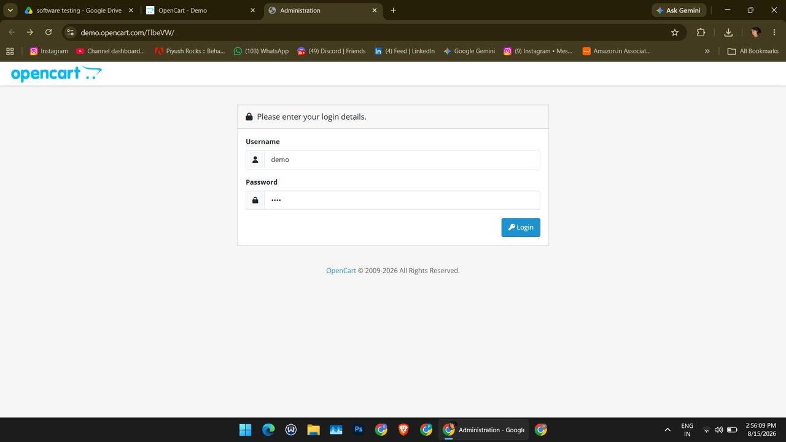
Screenshot (131)
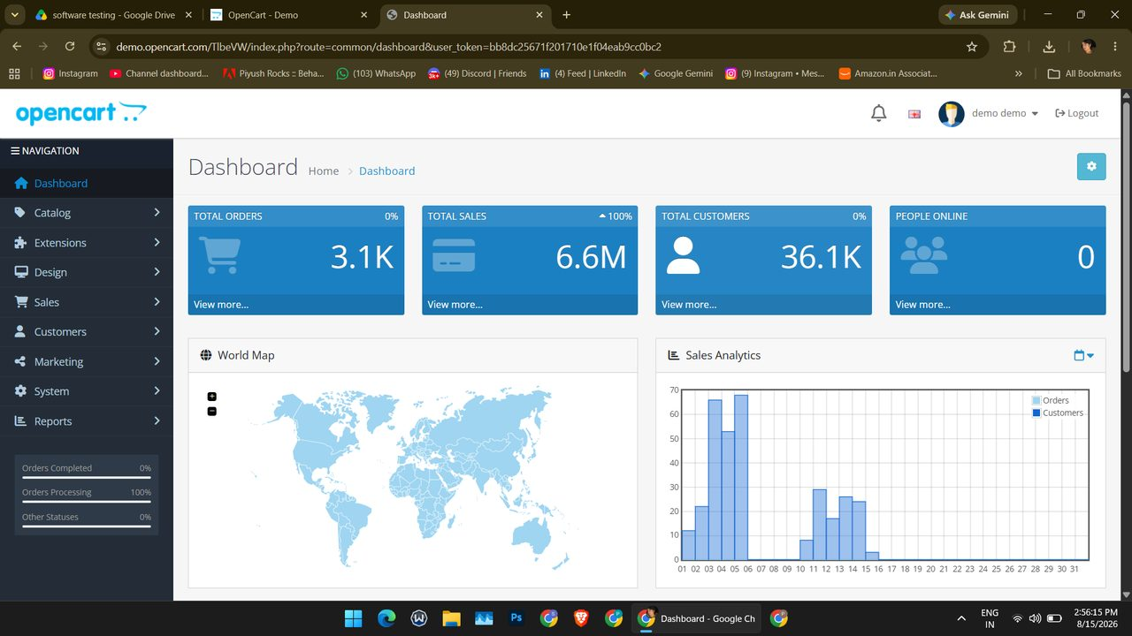
Screenshot (132)
TC008 — Login -> Dashboard (Integration)
Steps
- Log in to the administration panel.
- Observe the page shown after login.
Expected Result: Dashboard opens after login
Actual Result: Dashboard opened with Total Orders, Total Sales, Total Customers, World Map and Sales Analytics.
Status: Pass
Screenshot:
Screenshot (132)
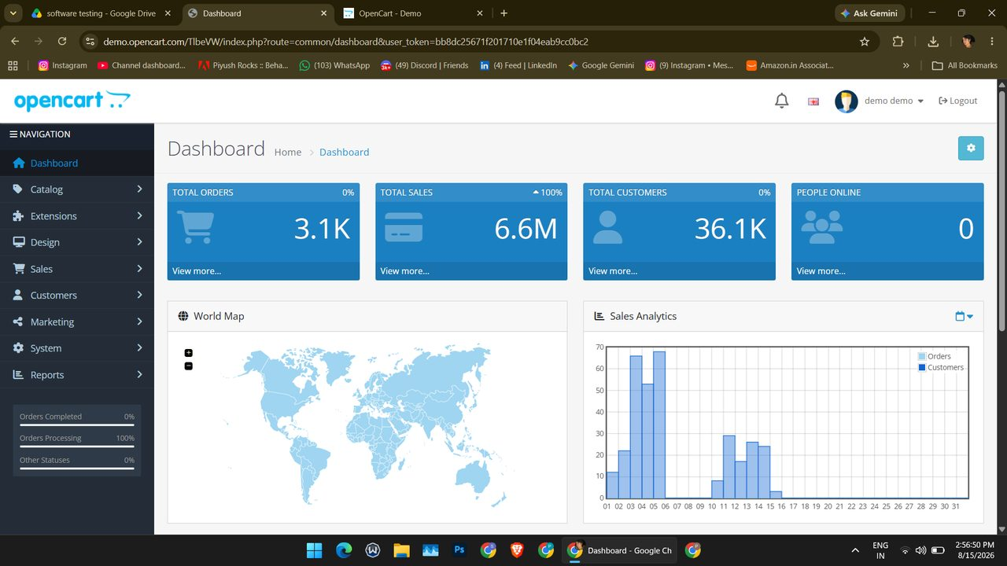
Screenshot (133)
TC009 — Dashboard -> Logout (Integration)
Steps
- From the Dashboard open the profile menu (demo demo).
- Click Logout.
- Observe the page shown.
Expected Result: Session ends; Login page shown
Actual Result: Session ended; administration Login page displayed.
Status: Pass
Screenshot:
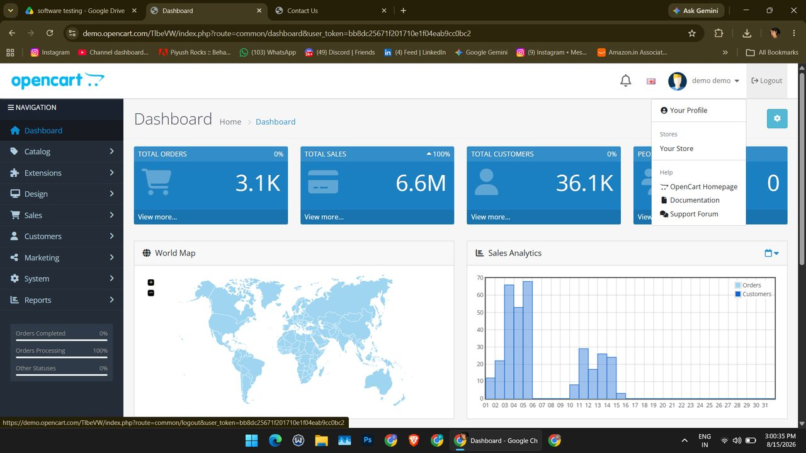
Screenshot (149)
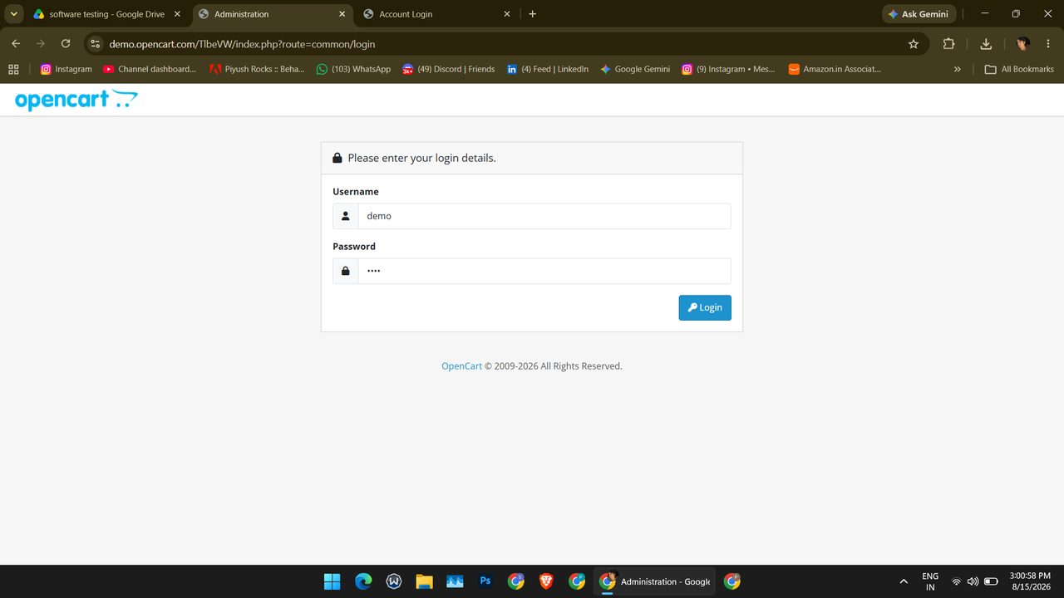
Screenshot (151)
TC010 — Navigate site pages (System)
Steps
- Open opencart.com and check the top menu (Features, Demo, Marketplace, Blog, Download, Login, Register).
- Open the demo store, click My Account and choose Login.
- Choose Register from the same menu.
- Open Contact Us from the footer.
Expected Result: Each page loads without error
Actual Result: Home, Login, Register and Contact Us pages loaded without error. (Features, Marketplace, Blog and Download were not opened.)
Status: Pass
Screenshot:
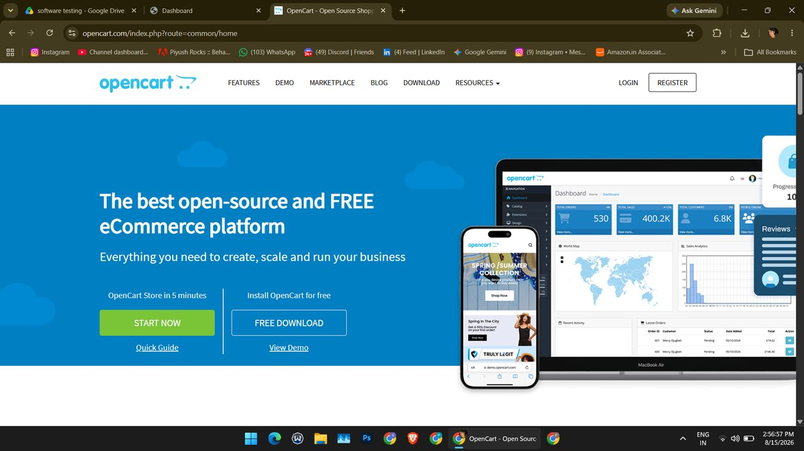
Screenshot (134)
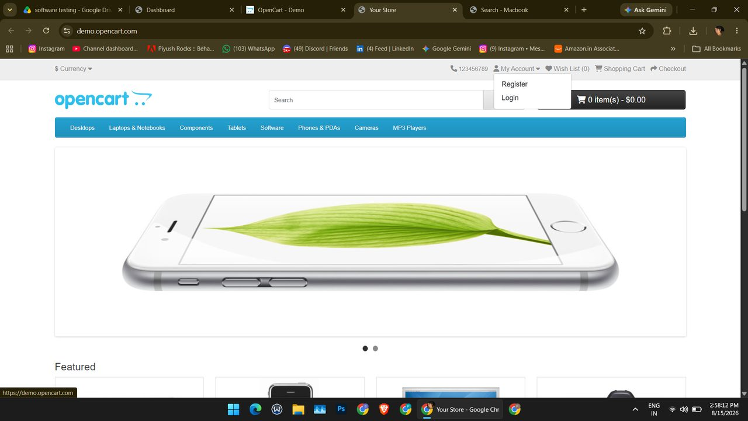
Screenshot (139)
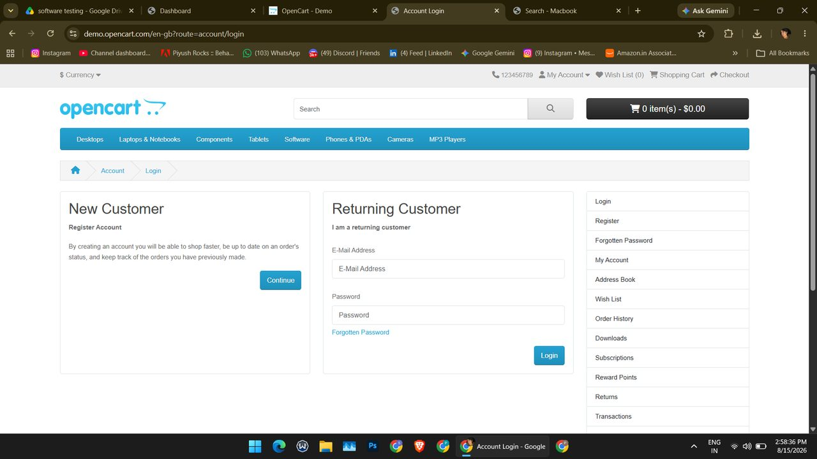
Screenshot (140)
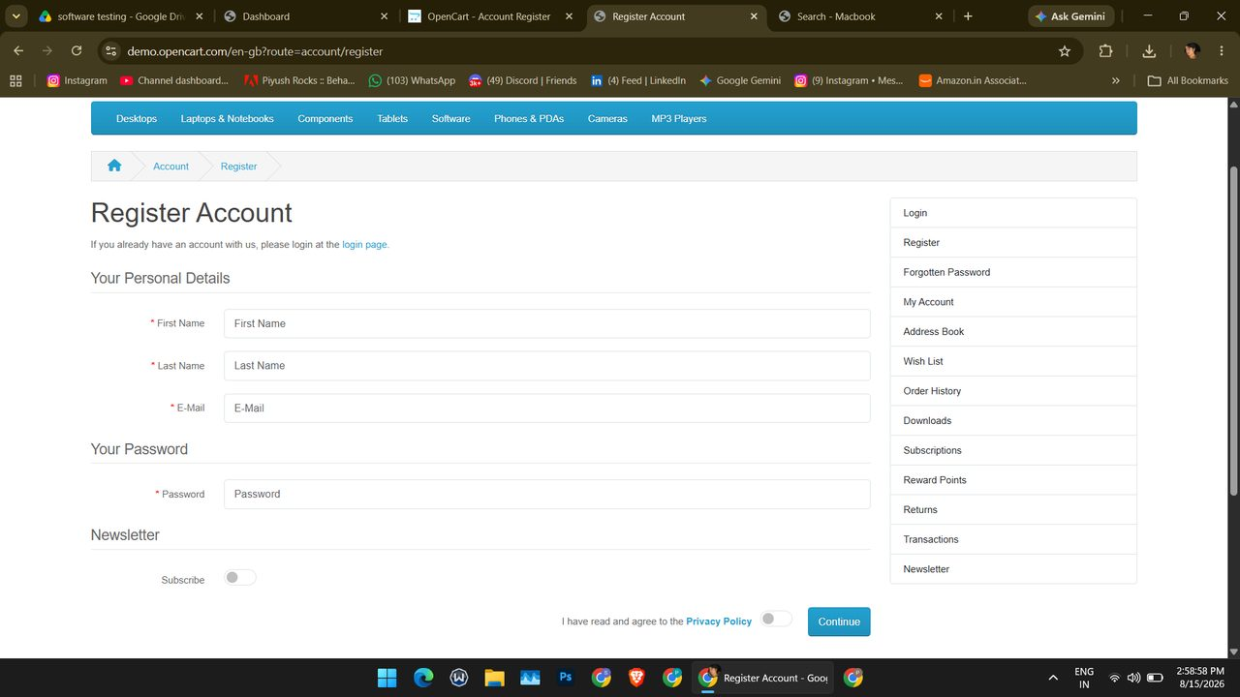
Screenshot (141)
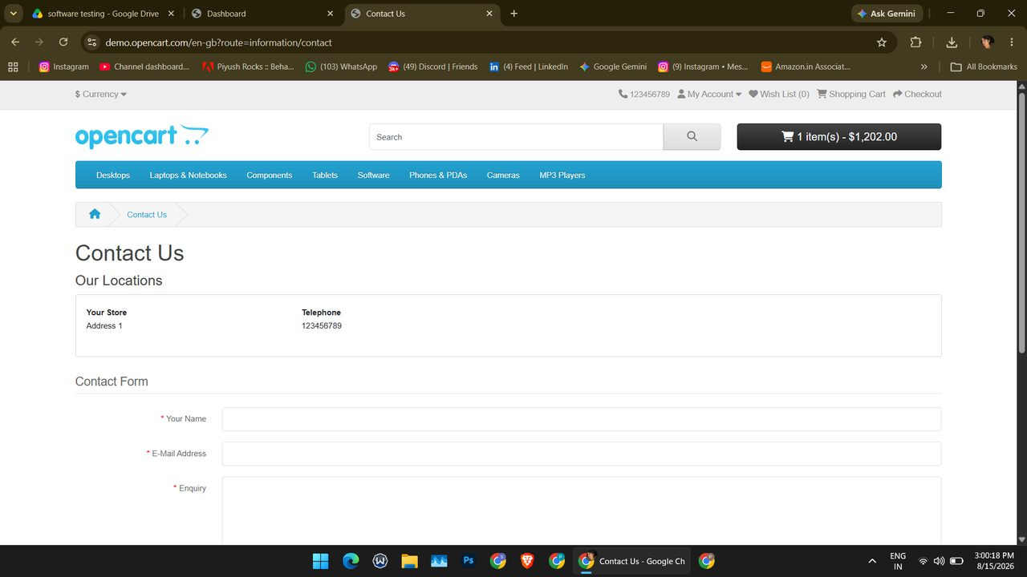
Screenshot (148)
TC011 — End-to-end shopping journey (System)
Steps
- Open the demo store home page and type "Macbook" in the search box.
- Open the search results (3 products).
- Open MacBook Air and click Add to Cart.
- Open the cart drop-down.
Expected Result: Complete flow works
Actual Result: Search listed MacBook, MacBook Air and MacBook Pro; success message shown after Add to Cart; mini cart shows MacBook Air x1, total $1,202.00.
Status: Pass
Screenshot:
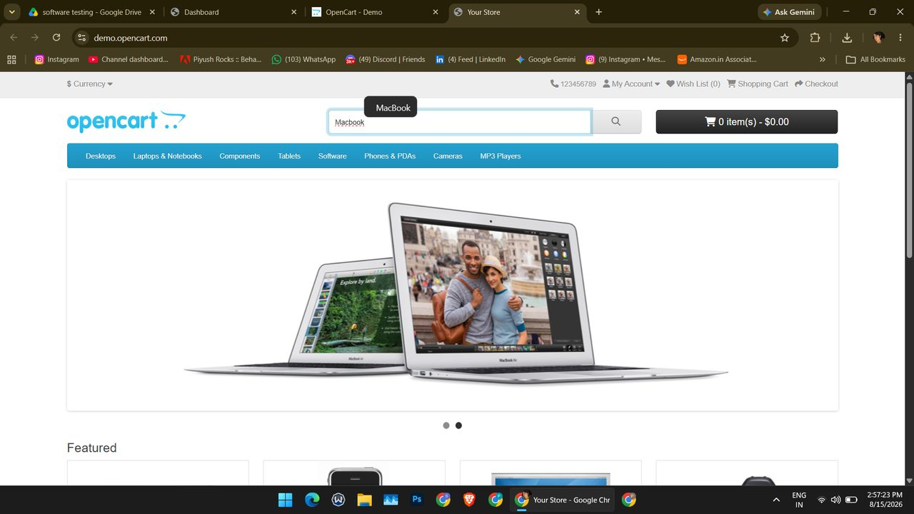
Screenshot (135)
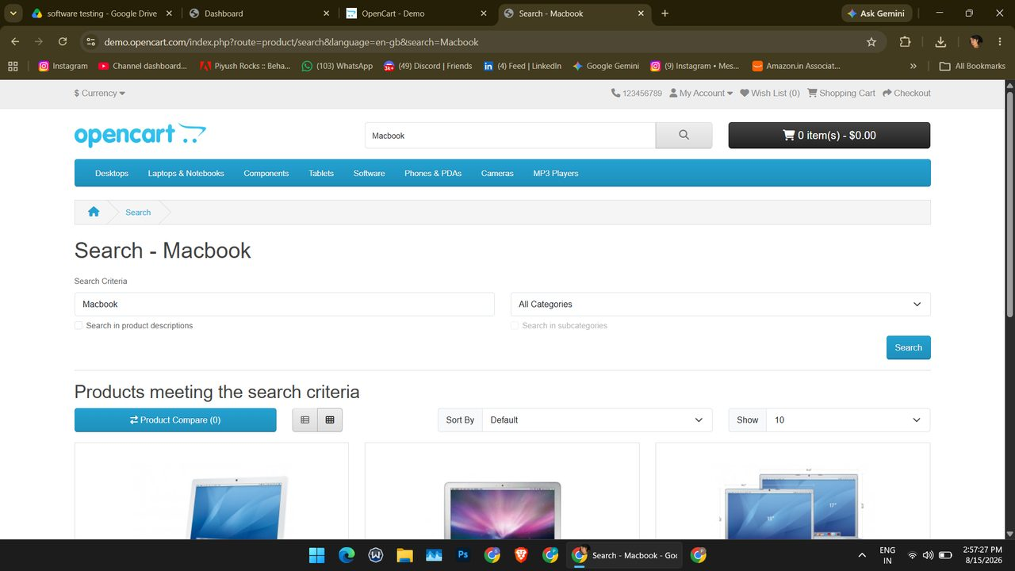
Screenshot (136)
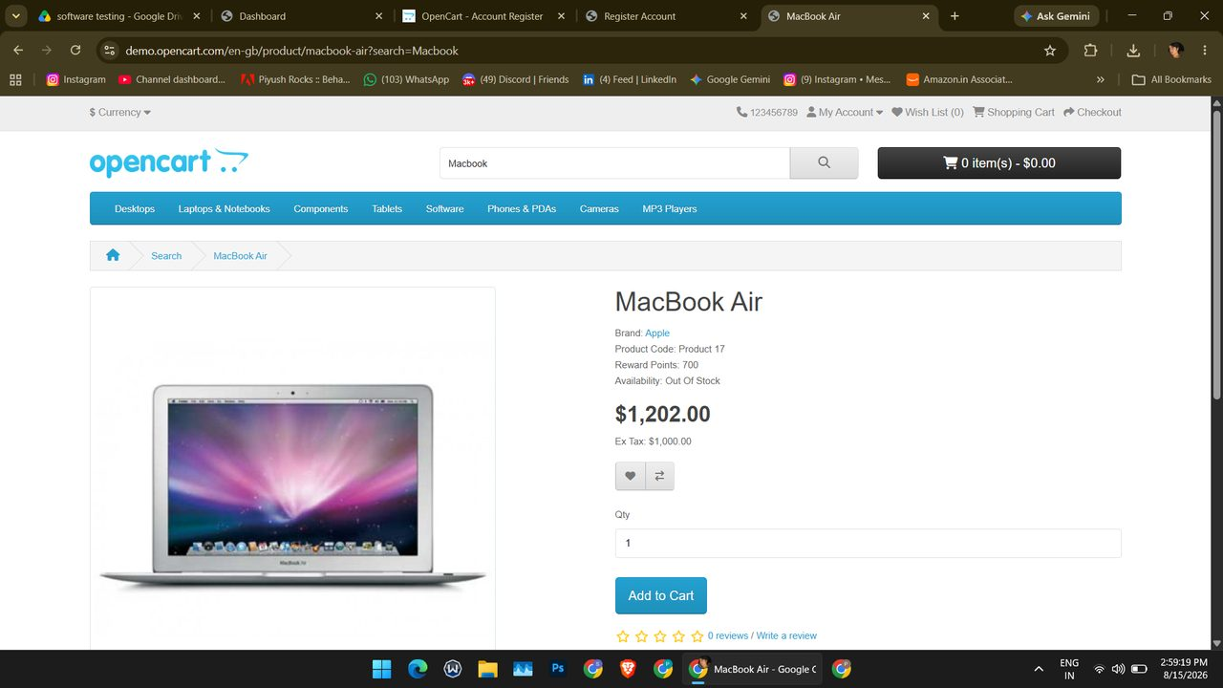
Screenshot (143)
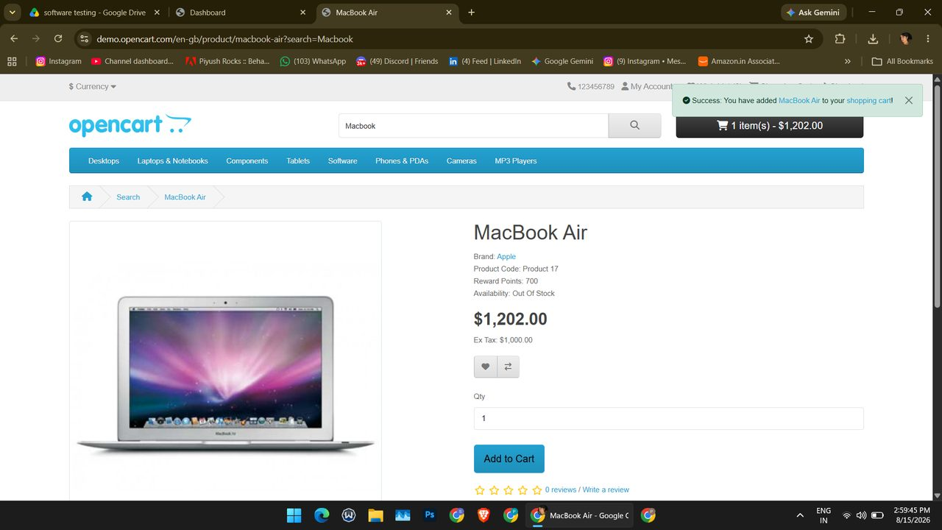
Screenshot (144)
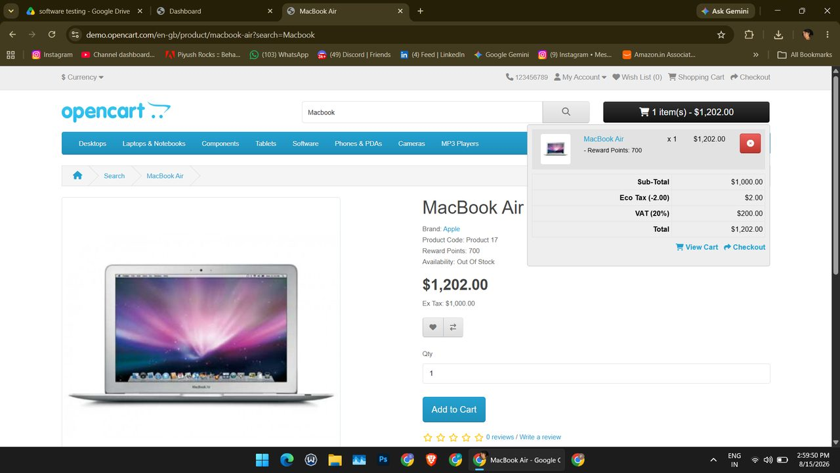
Screenshot (145)

Summary of Execution
Metric | Value
Total test cases | 11
Executed (Pass + Fail) | 8
Passed | 8
Failed | 0
Blocked | 0
Not Executed | 3
Pass % of executed | 100.0%
Pass % of total | 72.7%

Technique | Total | Pass | Fail | Not Executed
Black-Box | 4 | 1 | 0 | 3
White-Box | 3 | 3 | 0 | 0
Integration | 2 | 2 | 0 | 0
System | 2 | 2 | 0 | 0
Total | 11 | 8 | 0 | 3

